# **Lesson Objectives**

* 1. Zero Product Property
  2. Solve by Factoring GCF
  3. Solve by Factoring $x^{2}+bx+c=0$ into binomial factors
  4. Solve by Square Root Method
  5. Solve by the Quadratic Formula
  6. Using the Discriminant
  7. Solve by Graphing (find *x*-intercepts) on Calculator

# **Zero Product Property**

**If *a* ∙ *b* = 0, then either or .**

* **EXAMPLE:** Solve. $\left(13s+8\right)\left(5s-15\right)=0$ [*Beecher 3.2.1]

By the Zero Product Property,

**Set each** factor (parentheses) **equal to zero**: $13s+8=0$ or $5s-15=0$

Solve each equation.

(both are solutions) $s=$ or $s=$

# Solve by **Factoring GCF**

* **EXAMPLE:** Solve the quadratic equation. $9x^{2}=54x$ [3.2-1]

**NEVER** divide by a _______________! Don’t do this: $\frac{9x^{2}}{9x}=\frac{54x}{9x}$ no, No, NO!!! Bad! Stop it!

Very illegal!

Set your equation **equal** to **ZERO**! $9x^{2}=54x$

Then, you can **FACTOR out the GCF:**

Now, use the **Zero Product Property**: $=0$ or $=0$

Solve each equation:

(both are solutions) $x=$ **or $x=$**

# Solve by **Factoring $x^{2}+bx+c=0$ into Binomial Factors**

* **EXAMPLE:** Solve the equation by factoring. $x^{2}=3x+40$ [*Blitzer 1.5.3-Setup & Solve]

Set your equation **equal** to **ZERO**! $x^{2}=3x+40$

Try to factor:

Open 2 sets of parentheses with variable in the first position:

= $(x )(x )$

Next, we need 2 integers whose SUM is _____ and whose PRODUCT is _____

|  |  |  |
| --- | --- | --- |
| To finish factoring, we need 2 numbers: | | |
| **Product = -40**  (opposite signs) | **Sum = -3**  (opposite signs means SUBTRACT) | **Winner?** |
| $$± ∙∓ =-40$$ | $$± +\left(∓ \right)=∓$$ |  |
| $$± ∙∓ =-40$$ | $$± +\left(∓ \right)=∓$$ |  |
| $$± ∙∓ =-40$$ | $$± +\left(∓ \right)=∓$$ |  |
| $$± ∙∓ =-40$$ | $$± +\left(∓ \right)=∓$$ |  |

$x^{2}-3x-40$ factors into:

Rewrite the equation in factored form $x^{2}-3x-40=0$

$=0$

By the Zero Product Property, set each factor (parentheses) equal to zero:

$=0$ or $=0$

So, $x=$ or $x=$ (both are solutions)

The solution set is $\left\{ , \right\}$.

# Solve by the **______________ ___________** Method

The **Square Root Method** is used when only the **SQUARED** term and the **_________________** term are present. That is, the **Square Root Method** is used when your equation is of the form: $ax^{2}-c=0$.

There is no *x* term – only an *x*2 term and a constant term.

* **EXAMPLE:** Solve the quadratic equation. Check the answer. $4x^{2}-256=0$ [3.2.5]

Because no “*x*” term, **ISOLATE** the **SQUARED** part: $4x^{2}=256$ (add 256)

Continue to **ISOLATE** the **SQUARED** part: (divide by 4)

(take square root)

(What number could you square to get 64?)

**REALLY IMPORTANT!** Don’t forget the $____$ symbol! $x=$ or $\left\{ , \right\}$

* **EXAMPLE:** Solve the following equation. ${\left(x+21\right)}^{2}=11$ [3.2.29]

First, **________________** the **SQUARED** part. (DONE!) ${\left(x+21\right)}^{2}=11$

Take the **_____________ _________** both sides:

Simplify, if needed. Don’t forget the “plus or minus”

Solve for *x* by subtracting 21:

$x=$

(proper format is ______________ part first, followed by the _________________ part)

Can also be written as: $\left\{ , \right\}$

# Solve by the **Quadratic Formula**

The **Quadratic Formula:** Given $ax^{2}+bx+c=0$ (with *a* ≠ 0)

the solutions are: $x=\frac{ }{ }$ or $x=\frac{ }{ }$

Make sure you do the following:

* + - 1. Set your equation **EQUAL** to **________________**, if needed.
      2. Correctly identify the values for *a*, *b*, and *c*.
      3. Watch out for negatives! (Use parentheses)
* **EXAMPLE:** Solve the quadratic equation. $x^{2}+6x+9=14$ [3.2-4]

Set your equation **equal** to **ZERO**! $=0$ (subtracted 14)

You can try to factor first. If it doesn’t factor, use the **Quadratic Formula**.

NOTE: You can ALWAYS use Q.F. for ANY quadratic equation, even if other methods do (or don’t) work.

Use **Quadratic Formula**: $x=\frac{-b ± \sqrt{b^{2}-4ac}}{2a}$ with $a= , b= , c=$

Plug in your values: $x=\frac{ }{ }$

Simplify inside the square root (no decimals!) $x=\frac{ }{ } =\frac{ }{ }$

Simplify the square root itself:

(pairs and spares, Section R.7)

Now update the solution above: $x=\frac{ }{ }=\frac{ }{ }$

The common denominator is 2. **PULL them APART! $x=\frac{ }{2}=\frac{ }{2}±\frac{ }{2}$**

Reduce each fraction (ignore square root part) $x=\frac{ }{2}±\frac{ }{2}= ±$

The solutions are: $x= ±$ or $\left\{ , \right\}$

Mrs. E! Is there…maybe…an EASIER way to do that last example? Let’s revisit it:

* **EXAMPLE:** Solve the quadratic equation. $x^{2}+6x+9=14$ [3.2-4]

There is an interesting opportunity here! Look at just the LEFT side of the equation – do NOT set it equal to zero.

$$x^{2}+6x+9$$

Let’s **factor** that. $x^{2}+6x+9= =$

Revisit the equation: $x^{2}+6x+9=14$

Put factored form on the LEFT. ${( )}^{2}=14$ Use **square root** property.

Simplify. Don’t forget the $±$ symbol. Subtract 3.

The solutions are: $x= ±$ or $\left\{ , \right\}$

# Using the **Discriminant**

Recall the **Quadratic Formula:** Given $ax^{2}+bx+c=0$ (with *a* ≠ 0)

the solutions are: $x=\frac{-b ± \sqrt{b^{2}-4ac}}{2a}$

The expression inside the square root (the *radicand*), the $________________________$ is called the **________________________**, which can determine the **number of ________________** to the quadratic equation.

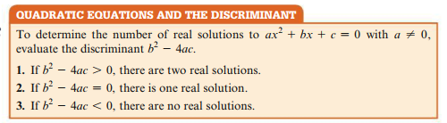

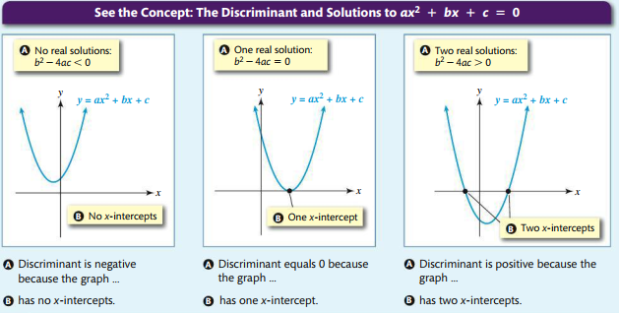

* **EXAMPLE:** Use the discriminant to determine the number of real solutions.

$w^{2}-2w+3=0$ [3.2-29]

$a=___, b=____, c=___$

$b^{2}-4ac=$

___________________________________________

Since the discriminant $b^{2}-4ac_____0$ (_________________), the equation will have:

**_______** **real solutions**.

Another (easier?) way: **GRAPH** the equation $w^{2}-2w+3=0$ on calculator

(use *x* as your variable)

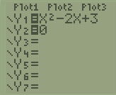 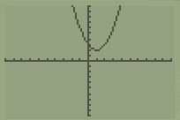

(Put left side equation in Y1, right side in Y2) (standard window Zoom 6)

Because the parabola does **_________** have any *x*-intercepts,

then that also means it has **_______ real solutions**.

# Solve by **Graphing** (**finding *x*-intercepts**) on **Calculator**

To solve a quadratic equation by graphing:

1. Set your equation **equal** to **__________**, if needed. Go to **Y=** on calculator. 
2. Put **left** side of equation into **____** and

**right** side (zero) into **___** on calculator (use *x* as your variable).

1. Graph starting with standard window, _________________.

You may need to Zoom In or Out (ENTER), if needed.

1. Does your graph (parabola) cross or touch *___*-axis?

If YES, go to STEP 5 to find *x*-intercepts.

If ____, then stop – your equation has **_____ real solutions**.

1. Press **_______**, **______________**, **___** (Intersect). 
2. Press DOWN Arrow to switch to Y2=0

and move cursor to where the parabola is touching *x*-axis.

1. Press **ENTER** _____ times.
2. You should see the word INTERSECTION with

*x* = some number and *y* = 0. This is an ***x*-intercept**.

1. The **solution** is the ***x*-coordinate** of that *x*-intercept (round the amount accordingly).
2. Repeat STEPS 5 through 9 if there is a second *x*-intercept. It will be the second **solution**.

* **EXAMPLE:** Use a calculator to find the graphical solution to the equation.   
  Round to the nearest thousandth.

$2n^{2}=-8n-5$ [3.2-16]

Set your equation equal to zero (add 8*n* and add 5)

$_________________________=0$ Go to Y= on calculator. Use *x* as your variable.

|  |  |  |  |
| --- | --- | --- | --- |
| Y1 = $2x^{2}+8x+5$ Y2 = 0 | ZOOM 6 to graph | 2nd TRACE 5  Left *x*-int. $x≈__________$ | 2nd TRACE 5 again  Right x-int. $x≈_________$ |
|  |  |  |  |

The solutions to the equation $2n^{2}=-8n-5$ are $n≈____________$**or $_____________$** (rounded to thousandth)

Sources Used:

1. MyLab Math for *College Algebra with Modeling and Visualization*, 6th Edition, Rockswold, Pearson Education Inc.
2. Wabbitemu calculator emulator version 1.9.5.21 by Revolution Software, BootFree ©2006-2014 Ben Moody, Rom8x ©2005-2014 Andree Chea. Website <https://archive.codeplex.com/?p=wabbit>